# **Website Designing (Module – 8 bootstrap basic & Advanced**

**(Q.1)** **What are the advantages of Bootstrap?**

**(ANS):**

Bootstrap is a popular open-source front-end framework that simplifies the process of designing and building responsive and mobile-first web pages. Here are some advantages of using Bootstrap:

1. ***Responsive Design:*** Bootstrap is built with a mobile-first approach, making it easy to create responsive designs that work well on various devices and screen sizes. It provides a grid system and responsive utilities for creating flexible layouts.
2. ***Consistency:*** Bootstrap offers a consistent and standardized set of styles and components, which helps maintain a cohesive and professional look across different sections of a website or web application. This consistency can save time and effort in the design and development process.
3. ***Cross-browser Compatibility:*** Bootstrap is designed to be compatible with major web browsers, ensuring that your website or application looks and functions consistently across different browsers.
4. ***Time-saving:*** Bootstrap comes with a pre-built set of CSS and JavaScript components, such as navigation bars, buttons, forms, and more. This reduces the need to write custom code for common elements, saving development time.
5. ***Customizable:*** While Bootstrap provides a default set of styles and components, it is highly customizable. Developers can easily customize the framework to match the specific design requirements of their project. There are also themes and templates available to further speed up the customization process.
6. ***Community and Documentation:*** Bootstrap has a large and active community of developers. This means there are plenty of resources, tutorials, and forums available for support. The official documentation is comprehensive, making it easy for developers to learn and use Bootstrap effectively.
7. ***Integration with JavaScript Libraries:*** Bootstrap seamlessly integrates with popular JavaScript libraries like jQuery. This makes it easy to enhance the functionality of your website or application by incorporating additional interactive elements.
8. ***Extensive Component Library:*** Bootstrap provides a rich set of UI components, such as navigation bars, modals, carousels, and more. These components are ready-to-use and can be easily customized, saving developers from having to build them from scratch.
9. ***Accessibility:*** Bootstrap follows best practices for web accessibility, ensuring that websites and applications built with Bootstrap are usable by people with disabilities. This is important for creating inclusive and accessible digital experiences.
10. ***Regular Updates:*** Bootstrap is actively maintained and updated, which means that developers can benefit from the latest features, bug fixes, and improvements. Regular updates also help ensure compatibility with the latest web standards and technologies.

Overall, Bootstrap is a versatile and powerful framework that streamlines the web development process, making it accessible to both beginners and experienced developers.

**(Q.2) What is a Bootstrap Container, and how does it work?**

**(ANS):**

In Bootstrap, a container is a fundamental layout element used to wrap and contain the content of a web page. It is part of the grid system provided by Bootstrap and plays a crucial role in creating responsive and organized layouts. The container class is used to establish a fixed-width container within the page, helping to control the layout and alignment of content.

There are two types of containers in Bootstrap: the .container class and the .container-fluid class.

1. ***.container:***

* The .container class creates a fixed-width container that adjusts its width based on the user's screen size. It is designed to be used for responsive layouts.
* The container has a predefined maximum width for different screen sizes, making it easy to create consistent and visually appealing designs.
* It adds padding to the left and right sides, ensuring that content does not reach the edges of the screen.

Example:



1. ***.container-fluid:***

* The .container-fluid class creates a full-width container that spans the entire width of the viewport.
* Unlike the .container class, it does not have a fixed maximum width, and it adjusts its size fluidly as the screen size changes.
* It also adds padding to the left and right sides, similar to the .container class.

Example:



***How it works:***

* When you use a container, it helps in organizing and structuring your content within a defined space, making it more readable and visually appealing.
* The container plays a crucial role in conjunction with the Bootstrap grid system. Rows and columns are placed inside containers to create a flexible and responsive layout. The grid system allows you to divide the container into a series of rows and columns, determining the placement of various elements on the page.
* By default, Bootstrap provides a responsive grid system with 12 columns. The width of these columns adjusts based on the width of the container, providing flexibility in designing layouts for different screen sizes.
* Containers ensure that the content remains within a specified width range, preventing it from stretching too wide on larger screens or becoming too cramped on smaller screens.

In summary, Bootstrap containers are essential for creating responsive and organized layouts, and they work in conjunction with the grid system to structure content within a specified space on a web page.

**(Q.3) What are the default Bootstrap text settings?**

**(ANS):**

Bootstrap provides a set of utility classes for manipulating text elements. These classes can be used to control various aspects of text, such as font size, font weight, alignment, and more. Here are some of the default Bootstrap text-related utility classes:

1. ***Font Size:***

* ***.text-xs:*** Extra small text.
* ***.text-sm:*** Small text.
* ***.text-md:*** Medium-sized text (default size).
* ***.text-lg:*** Large text.
* ***.text-xl:*** Extra-large text.
* ***.text-2xl, .text-3xl, ... :*** Additional classes for larger text sizes.

Example:



1. ***Font Weight:***

* ***.font-weight-bold:*** Sets the text to bold.
* ***.font-weight-normal:*** Resets the font weight to the default (normal).

Example:



1. ***Text Alignment:***

* ***.text-left:*** Aligns text to the left.
* ***.text-center:*** Centers text.
* ***.text-right:*** Aligns text to the right.
* ***.text-justify:*** Justifies text.

Example:



1. ***Text Color:***

* ***.text-primary, .text-secondary, .text-success, ... :*** Classes for setting text color based on Bootstrap's color scheme.
* ***.text-light, .text-dark:*** Light and dark text colors.

Example:



1. ***Text Transformation:***

* ***.text-uppercase:*** Converts text to uppercase.
* ***.text-lowercase:*** Converts text to lowercase.
* ***.text-capitalize:*** Capitalizes the first letter of each word.

Example:



These are just a few examples of Bootstrap's text utility classes. By using these classes, you can easily style and format text elements in your Bootstrap-powered web pages. Additionally, Bootstrap allows you to create custom styles for text by combining these utility classes as needed.

**(Q.4) What do you know about the Bootstrap Grid System?**

**(ANS):**

The Bootstrap Grid System is a responsive, mobile-first grid layout system that provides a structure for designing and organizing web page content. It is based on a 12-column grid, and the layout can be customized to accommodate various screen sizes, from large desktop monitors to small mobile devices. The grid system is a fundamental part of Bootstrap and is used to create flexible and responsive layouts.

Here are key features and concepts related to the Bootstrap Grid System:

1. ***Container:***

* The grid system is typically placed within a container. Bootstrap provides two types of containers: .container and .container-fluid. The former creates a fixed-width container, while the latter creates a full-width, fluid container.

Example:



1. ***Row:***

* Rows are used to group columns horizontally. Each row consists of 12 columns by default.

Example:



1. ***Column:***

* Columns are the building blocks of the grid system. Content is placed within columns, and columns are placed within rows.
* Columns are specified using classes such as .col-, followed by the desired width for a specific screen size (e.g., .col-md-6 for a column that spans 6 columns on medium-sized screens).
* The total number of columns in a row should not exceed 12.

Example:

1. ***Responsive Classes:***

* Bootstrap provides responsive classes to specify column widths based on different screen sizes. These classes include .col-xs-, .col-sm-, .col-md-, and .col-lg-.
* For example, .col-md-6 sets the column width to 6 columns on medium-sized screens and above.

Example:

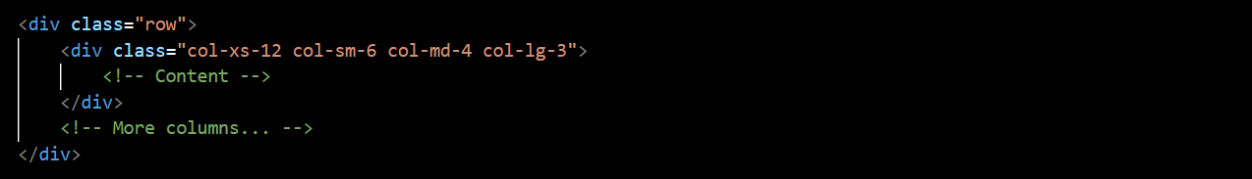

1. ***Offsets and Nesting:***

* Bootstrap allows for column offsets using classes like .offset-. This helps in creating spacing between columns.
* Columns can be nested within other columns to create more complex layouts.

Example:

1. ***Alignment and Ordering:***

* Bootstrap provides classes for aligning columns vertically (align-self-) and horizontally (justify-content-).
* Columns can be ordered using classes like .order-.

Example:

The Bootstrap Grid System is a powerful tool for creating responsive and flexible layouts. By using a combination of containers, rows, and columns with responsive classes, developers can design web pages that adapt well to various screen sizes and devices.

**(Q.5) What do you know about the Bootstrap Grid System?**

**(ANS):**

As of my last knowledge update in January 2022, Bootstrap 5 had been released, and there were several key differences between Bootstrap 4 and Bootstrap 5. However, it's essential to note that updates and changes to frameworks can occur over time, and it's possible that there have been further updates or modifications since then. Here are some of the notable differences between Bootstrap 4 and Bootstrap 5:

1. ***Dropped jQuery Dependency:***

* One significant change in Bootstrap 5 is the removal of the dependency on jQuery for JavaScript components. Bootstrap 5 encourages the use of modern JavaScript, such as vanilla JavaScript or a JavaScript framework like Vue.js or React.

1. ***Customizable and Lighter:***

* Bootstrap 5 is designed to be more modular and customizable. It allows developers to pick and choose the components they need, resulting in a lighter and more efficient framework. This approach contrasts with Bootstrap 4, which included a more monolithic set of components.

1. ***New Utility Classes:***

* Bootstrap 5 introduced new utility classes for spacing, typography, and color manipulation. These classes provide more flexibility and control over the appearance of elements.

1. ***Improved Grid System:***

* While the overall grid system structure remains similar, Bootstrap 5 introduced improvements such as a new grid tier (xxl) for even larger screens, enhanced gutter classes, and a more consistent spacing system.

1. ***Updated Forms and Components:***

* Bootstrap 5 includes updates to forms and components, providing new styles and options for customization.

1. ***Removal of Card Decks:***

* Bootstrap 5 removed the card-deck class, and developers are encouraged to use the grid system for creating card layouts instead.

1. ***New Logo and Branding:***

* Bootstrap 5 introduced a new logo and branding to give the framework a fresh and modern look.

1. ***Documentation Improvements:***

* The documentation for Bootstrap 5 has been improved and refined, making it more user-friendly and providing better guidance for developers.

It's always a good idea to check the official Bootstrap documentation or release notes for the most up-to-date information. If there have been further updates or new versions released after my last knowledge update in January 2022, you may find additional features or changes in subsequent releases.

**(Q.6) What is a Button Group, and what is the class for a basic Button Group?**

**(ANS):**

In Bootstrap, a button group is a group of buttons that are visually grouped together. Button groups are useful for presenting related actions or options in a compact and organized manner. They can be styled to appear as a cohesive unit, and different styles can be applied to create segmented button groups.

The basic class for a button group in Bootstrap is .btn-group. This class is used to wrap a set of button elements to create a button group. There are variations of button groups, including segmented button groups and button toolbars.

Here's an example of a basic button group:

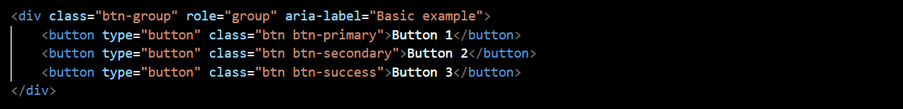

In this example:

* The btn-group class is applied to the <div> element, indicating that it is a button group.
* The role="group" attribute is used for better accessibility, indicating that the div serves as a group of buttons.
* The aria-label="Basic example" attribute provides a label for assistive technologies, describing the purpose of the button group.

The individual buttons within the group have their respective button classes (e.g., btn-primary, btn-secondary, btn-success). You can customize the appearance and behavior of the buttons based on your design requirements.

Button groups can be further customized using additional classes and options, such as:

* .btn-group-lg for a large-sized button group.
* .btn-group-sm for a small-sized button group.
* .btn-group-vertical for a vertically stacked button group.
* Various spacing and sizing classes for fine-tuning the appearance.

Here's an example of a vertically stacked button group:

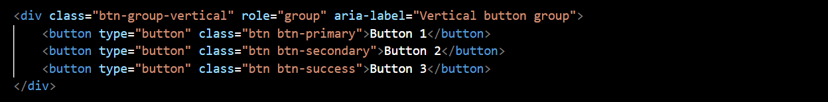

Button groups provide a convenient way to organize and style related buttons in your user interface.

**(Q.7) How can you use Bootstrap to make thumbnails?**

**(ANS):**

In Bootstrap, you can create thumbnails using the .card component to wrap images or other content. Thumbnails are small, bordered containers that can contain images, text, or other media. Here's a basic example of how you can use Bootstrap to create thumbnails:

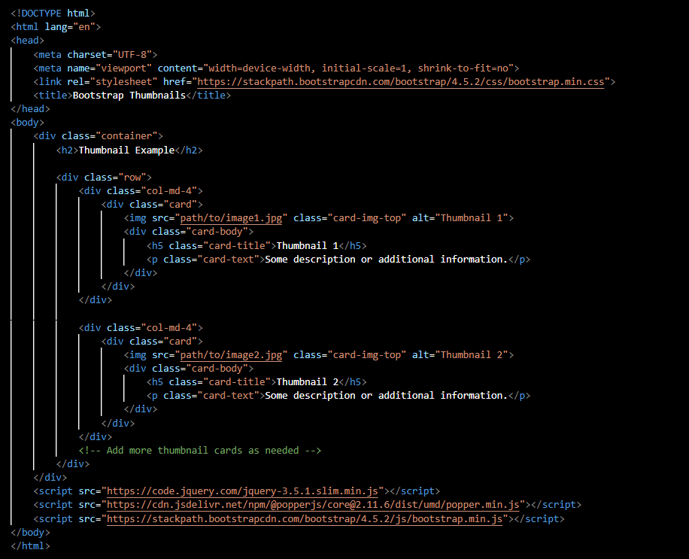

In this example:

1. The Bootstrap CSS and JavaScript files are included from a CDN for styling and functionality.
2. The container class is used to create a responsive fixed-width container.
3. Inside the container, a row class is used to create a horizontal grouping of thumbnail cards.
4. Each thumbnail is created using the .card class.
5. The .card-img-top class is used to position the image at the top of the card.
6. The .card-body class is used for the body of the card, where you can include the title (card-title) and text (card-text) for the thumbnail.

You can add more thumbnail cards by duplicating the col-md-4 div and adjusting the content accordingly.

Customize the content, images, and styles based on your specific needs. You can also explore additional features and options provided by Bootstrap's card component to enhance the appearance and functionality of your thumbnails.

**(Q.8) In Bootstrap 4, what is flexbox?**

**(ANS):**

In Bootstrap 4, the Flexbox (Flexible Box Layout) model is a powerful layout system used for designing responsive and flexible web pages. Flexbox provides a more efficient and predictable way to arrange, distribute, and align items within a container, even when the size of the items or the container is unknown or dynamic.

Flexbox is implemented in Bootstrap 4 to create the grid system, which is used for building responsive and flexible layouts. Here are key concepts related to Flexbox in Bootstrap 4:

1. ***Flex Container:***

* The parent element containing one or more flex items is known as the flex container.
* In Bootstrap 4, the .d-flex class is used to make an element a flex container. This class can be applied to various HTML elements such as <div>, <ul>, or <nav>.

Example:



1. ***Flex Items:***

* The child elements of a flex container are referred to as flex items.
* By default, flex items are laid out in a row, but you can change this direction using additional utility classes.
* Bootstrap provides classes like .flex-row, .flex-column, .flex-row-reverse, and .flex-column-reverse for changing the direction of the flex items.

Example:



1. ***Flex Alignment:***

* Flexbox allows you to easily align flex items both horizontally and vertically.
* Bootstrap provides utility classes like .justify-content-* for horizontal alignment and .align-items-* for vertical alignment. Replace * with values like start, end, center, between, and around for different alignment options.

Example:



1. ***Flex Order:***

* You can control the order of flex items using the .order-* utility class. Lower values for * will bring the item to the beginning, while higher values will move it toward the end.

Example:

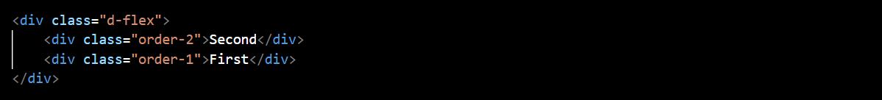

1. ***Responsive Flex Utility Classes:***

* Bootstrap provides responsive utility classes for applying Flexbox properties based on screen size.
* For example, you can use classes like .d-sm-flex to apply Flexbox for small screens and larger.

Example:



The use of Flexbox in Bootstrap 4 simplifies the creation of flexible and responsive layouts, making it easier to adapt to different screen sizes and device orientations. The combination of the grid system and Flexbox provides a powerful and versatile approach to web layout design.

**(Q.9) How can one create an alert in Bootstrap?**

**(ANS):**

In Bootstrap, you can create alerts using the .alert class along with contextual classes to define the appearance and color of the alert. Alerts are useful for displaying important messages or information to the user. Here's a basic example of how to create an alert in Bootstrap:

In this example:

1. The Bootstrap CSS and JavaScript files are included from a CDN for styling and functionality.
2. The .alert class is used to create the basic structure of the alert.
3. Contextual classes like .alert-primary, .alert-secondary, etc., are used to define the color and style of the alert. Choose the class that corresponds to the desired visual style.
4. The role="alert" attribute is added for accessibility purposes, indicating that the element serves an alert role.

You can customize the content and appearance of the alert based on your specific requirements. Additionally, Bootstrap provides dismissible alerts, which include a close button for users to dismiss the alert. To create a dismissible alert, add the .alert-dismissible class and a close button inside the alert.

**(Q.10) What is a bootstrap card and how would you create one?**

**(ANS):**

In Bootstrap, a card is a flexible and extensible container that can contain various types of content, including images, text, links, and more. Cards are a versatile component used to display information in a structured and visually appealing way. They are commonly used for presenting content like articles, blog posts, user profiles, and product details.

Here's a basic example of how you can create a simple Bootstrap card:

In this example:

1. The Bootstrap CSS and JavaScript files are included from a CDN for styling and functionality.
2. The .card class is used to create the basic structure of the card.
3. The style="width: 18rem;" attribute is added to set the maximum width of the card. You can adjust this based on your design preferences.
4. Inside the card, the .card-img-top class is used for the card's top image (you can replace the placeholder URL with your own image).
5. The .card-body class contains the main content of the card, including a title (card-title), some text (card-text), and a button (btn).

This is a simple example, and Bootstrap provides additional classes and options for customizing cards further. You can explore features like card headers, card footers, different card styles, and more to create cards tailored to your specific needs. Bootstrap's card component is highly flexible and can be extended to accommodate a wide range of content presentation scenarios.